3.7 Dividing in a ratio

Example:
Divide $360 in the ratio 5 : 4.
Step 1: The total number of parts
is 5 + 4 = 9
Step 2: The two shares are
× 360 and × 360
= $200 and $160
Franco and Richard have to share $360
in the ratio 5 : 4. This means that for each
$5 Franco receives, Richard receives $4.
Dividing a quantity in a given ratio
Step 1: Find the total number of parts.
(Add the numbers in the ratio.)
Step 2: Find the fraction of the
quantity for each share.

1 Find the total number of parts in these ratios.
a 2 : 3 ____ b 3 : 1 ____ c 4 : 3 ____
d 3 : 5 ____ e 4 : 5 ____ f 7 : 4 ____
2 Complete these ratio divisions.
a Divide $24 in the ratio 2 : 1. b Divide $32 in the ratio 1 : 3.
____________________________ ____________________________
____________________________ ____________________________
c Divide $50 in the ratio 2 : 3. d Divide $48 in the ratio 3 : 5.
____________________________ ____________________________
____________________________ ____________________________
e Divide $42 in the ratio 4 : 3. f Divide $80 in the ratio 3 : 2.
____________________________ ____________________________
____________________________ ____________________________
g Divide $55 in the ratio 4 : 7. h Divide $175 in the ratio 5 : 2.
____________________________ ____________________________
____________________________ ____________________________

3.7 Dividing in a ratio
continued

i Divide 120 cm in the ratio 1 : 4. j Divide 500 mL in the ratio 2 : 3.
____________________________ ____________________________
____________________________ ____________________________
k Divide 150 m in the ratio 7 : 8. l Divide 180 kg in the ratio 5 : 7.
____________________________ ____________________________
____________________________ ____________________________
m Divide 250 km in the ratio 3 : 2. n Divide 720 mm in the ratio 4 : 5.
____________________________ ____________________________
____________________________ ____________________________
Answer the following questions in your workbook.
3 Divide 1 kg (1 000 grams) in the ratio 3 : 2. Answer in grams.
4 Divide 1 hour (60 minutes) in the ratio 5 : 7. Answer in minutes.
5 Stephanie divided $48 in the ratio 2 : 1. What is the smaller share?
6 Dylan divided $200 in the ratio 2 : 3. What is the larger share?
7 What is the smaller share when $70 is divided in the ratio 3 : 7?
8 There are more girls than boys in Year 8 at Woodport Secondary College.
The ratio of girls to boys is 7 : 5. The total number of students in Year 8 is 204. How many girls are in Year 8?
9 The total area of a house is 160 square metres.
The ratio of the living area to the bedroom area is 5 : 3.
What is the living area in this house?
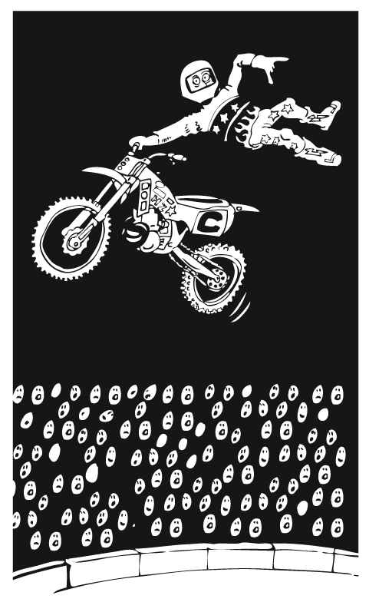
10 A sporting club received a grant of $20 000. The
grant was shared between new equipment and
team uniforms in the ratio 3 : 5. How much was
spent on team uniforms?
11 Two stunt riders are to compete for $3 500 in
prize money. The prize money will be divided
in the ratio 5 : 2. The winner will receive the
larger share. How much will the loser receive?

